Chapter 3 Study Guide
When I ask you to define a term do not just go to the margin definition, but read about the concept in your text for additional information. Make sure you completely understand what it is and always be able to recognize examples.
- What are the 2 basic growth patterns in infancy? DEFINE plus examples.

- How much does a baby’s weight increase by the time they turn 1? Height?

- DEFINE: neuron, cell body, dendrites, axon, myelinated, neurotransmitters, and synapses. Also make sure you can identify all structures listed below.
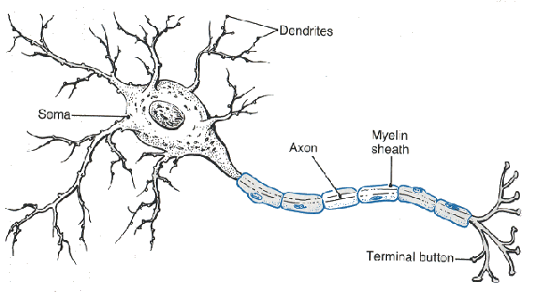

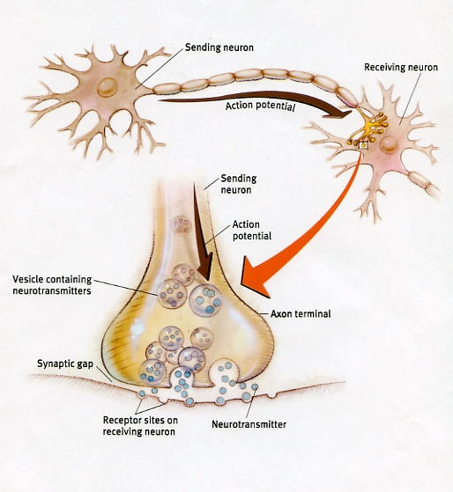

- When do neurons begin to develop? When is development complete? How fast are they created and how many do we have when born?

- What’s the function of myelination?

- What is the outer surface of the brain called and it’s functions?

- What are the functions of the two hemispheres and do infants have this specialization?

- How do we know we are genetically programmed to learn language?

- What affect, if any, does raising children in enriched versus impoverished environment have on them?

- What are the three major areas of the physical development? Explain Why is fat important? If cartilage hardens to bone from inner core out, what type of growth is that (see question 1).

- What three things is motor development based on?

- Approximately when do we begin to crawl? DEFINE crawling, creeping, hitching, cruising.

- DEFINE and know the order of development of the ulnar, palmar, radial, and pincer grasps.

- Describe the relationship of developing hand movement and visual perception.

- What is the name of the famous experiment by Gibson and Walk (1960)? Name and describe the apparatus and the experiment. When does depth perception (3 dimensional perception) begin?

- What are some of the benefits of breast-feeding compared to formula?

- What might be a reason not to breast-feed?

- How long do most medical professionals recommend breast-feeding?

- Why do medical professionals recommend waiting until 4 months to introduce infant cereal?

- What are some of the safety concerns during infancy?

- What is SIDS and the peak age?

- Define accommodation and assimilation (see ch 1).

- What is the difference between equilibrium and disequilibrium?

- Explain, “cognitive development is driven by adapting our thinking to our experiences in the world.”

- Where does the term sensorimotor come from?

- What is object permanence? How does this relate to peek-a-boo?

- What is another accomplishment, other than object permanence, during the sensorimotor stage?

- How many substages are there in the sensorimotor stage? DEFINE each and include the ages. DEFINE circular reactions.

- How does Piaget and information processing theory differ regarding continuous vs. discontinuous issues discussed in chapter 1?

- DEFINE explicit and implicit memories and their developmental timetables.

- What is and when do we believe association and recognition is first present?

- Explain how we test newborns’ ability to recognize objects?

- What have we learned from tongue protrusion tests?

- What is infantile amnesia?

- What are the three leading theories in regard to the causes of infantile amnesia?

- What does it mean that language acquisition is innate?

- What is the definition of language and speech?

- DEFINE: Phonemes, morphemes, syntax, semantics, and pragmatics.

- What is the Language Acquisition Device and who developed this theory?

- DEFINE motherese or infant directed speech. What do linguists support as a theory of language development?
- Describe the general sequence to language learning. Be sure to include ages.

- DEFINE holophrase, underextension, and overextension.

- Outline vocabulary development. When can most children effectively communicate?

- DEFINE emotions.

- Describe the mirror neuron system.

- What are the different theoretical viewpoints developmentalists have regarding emotions? Explain each.

- What are the four basic patterns of infant crying? Why is it important to never ignore infants cry?

- What are the two types of emotions? DEFINE each.

- List the primary emotions and which 2 are present at birth? When do the others develop?

- What is a social smile and when does it begin to appear? When do babies begin to laugh?

- What is stranger wariness and when does it develop? Why is it adaptive to develop at this time?

- List secondary emotions. When do they begin to appear?

- What are the 3 categories of temperament? Describe a typical baby in each category.

- DEFINE and provide an example of goodness-of-fit.

- What is attachment? Is it biological or cultural? How do you know?

- How is attachment a 2 way street?

- Outline the 4 phases of attachment.

- Briefly describe Ainsworth’s (1978) “the strange situation” study.

- DEFINE each attachment style and what percentage of infants fall into each.

- When does self-recognition start? Describe the classic self-awareness test.

- DEFINE all types of play.

- What age does cooperative play begin?

- What do the developmental consequences of daycare depend on?

- What psychosocial developmental period do we experience during infancy? Remember, we are going to label them based on positive vs negative outcomes. How does Erikson describe the positive resolution of trust (development of an attitude)? How might an attitude of mistrust develop?

- What is autonomy vs shame and what period of time do we experience this psychosocial developmental stage? What are some of the activities/interactions that can lead to autonomy? shame & doubt?

